VPN
VPN stands for Virtual Private Network and describes the opportunities to established a protected network the opportunities to establish a protected network connection when using pubic networks. A VPN connection established a secure connection between you and the internet.
VPN changes your apparent location by sending your to VPN traffic through a server in another location. VPN apps lets you select a server anywhere in the world where your VPN services has servers.

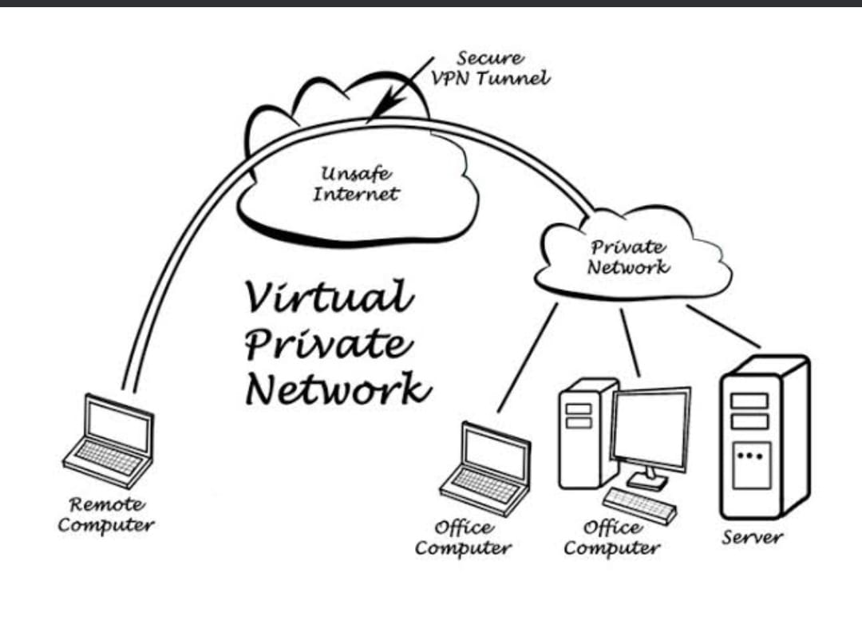

History of VPN
VPN history starts back in 1996, when a Microsoft employee (most sources say Gurdeep Singh Pall) started development the peer to peer Tunneling Protocol (PPTP). In 1999, the specification was published. Over time, VPNs and the concept behind his technology have changed drastically.

Benefits of VPN
- Hide your private information.
- Prevent Data Throttling.
- Avoid Band width Throttling.
- Get access to Geo- blocked services.
- Network scalability.
- Reduce support costs.

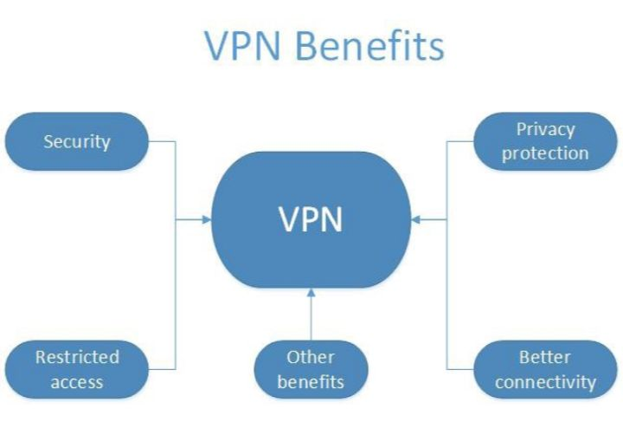

Types of VPN are-

- Remote Access VPN:- Remote Access VPN permits a user to connect to a private network and access all its services and resources remotely. The connection between the user and private network occurs through the Internet and the connection is secure and private. Remote Access VPN is useful for home users and business users both.
An employee of a company while he/she is out of solution, users a VPN to connect to his/her company’s private network and remotely access files and resources on the private network. Private users or home users of VPN, primarily use VPN services to enhance their internet security also use VPN services to enhance their internet security and privacy.
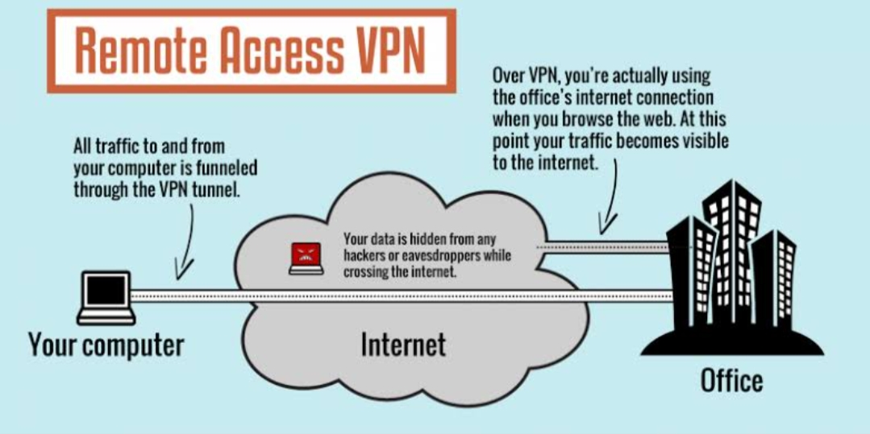

- Site to site VPN:- A site to site VPN is also called as router to router VPN and it is commonly used in the large companies. Companies or organization, with branch offices in different locations, use site to site VPN to connect to the network of one office location to the network at another office location.

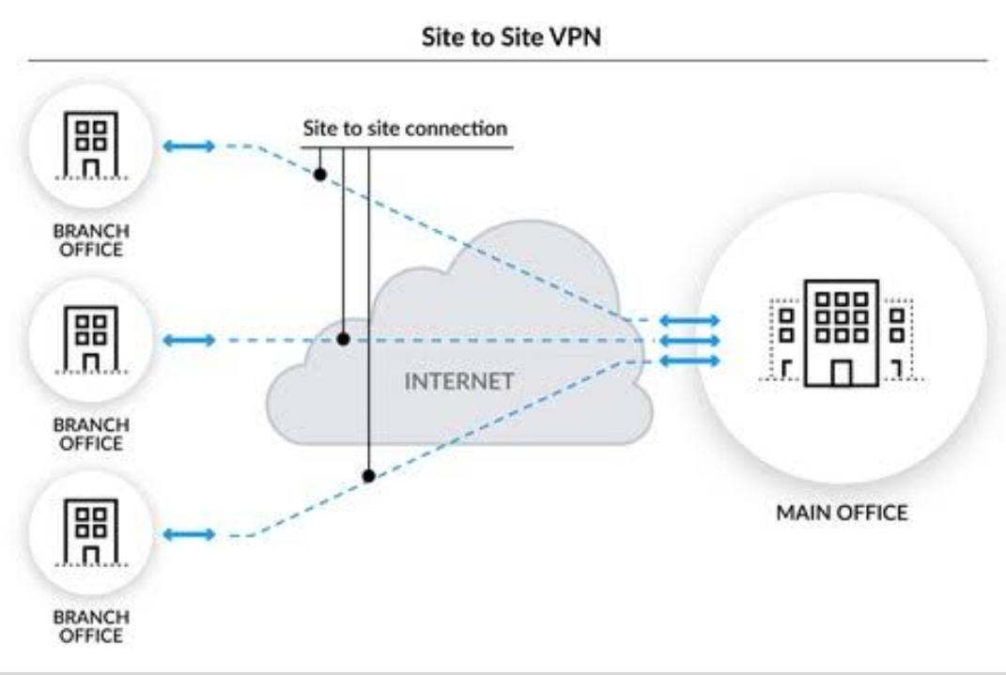

- Intranet based VPN- When several offices other same company are connected using site to site VPN type, it is called as Intranet based VPN.

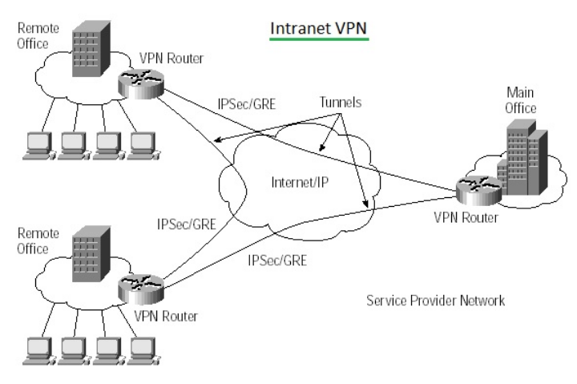

- Extranet based VPN:- When companies use site to site VPN type to connect to the offices of another company, it is called as Extranet based VPN.

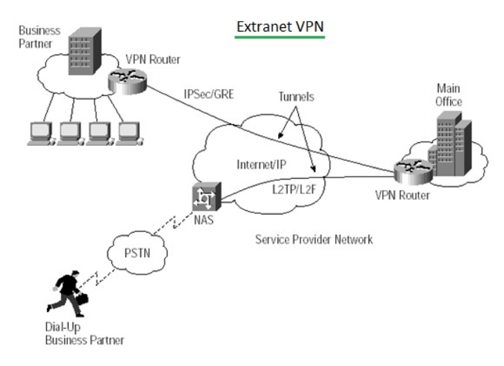

How to surf securely with a VPN?

A VPN encrypt your surfing behavior, which can only be decided with the help of a key. Only your computer and the VPN know this key, so your ISP cannot recognize where are surfing. Different VPN use different encryption processes, but generally function in three steps:-
- Once you are online, start your VPN. The VPN acts as a secure tunnel between you and the internet. Your ISP and other third parties cannot detect this tunnel.
- Your devices is now on the local network of the VPN, and your IP addressed can be changed to an IP address provided by the UPN servers.
- You can now surf the internet at will, as the VPN protect all your personal data.

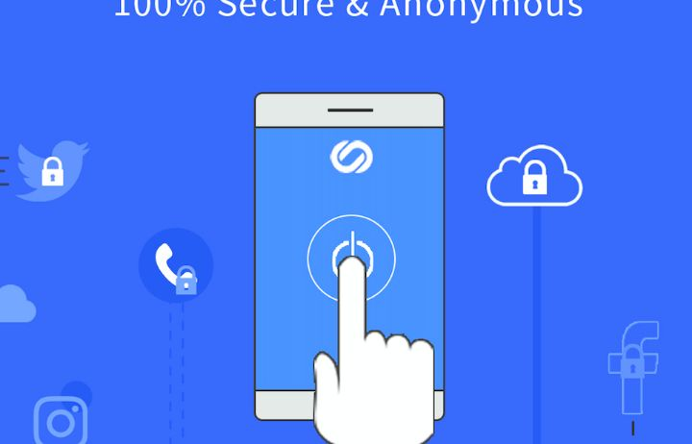
What should a good VPN do?

You should rely on your VPN to perform one or more tasks. The VPN itself should also be protected against compromise.
Encryption of your IP address:- The primary job of a VPN is to hide your IP address from your ISP and other third parties. This allows you to send and receive information online without the risks of anyone but you and the VPN provider seeing it.

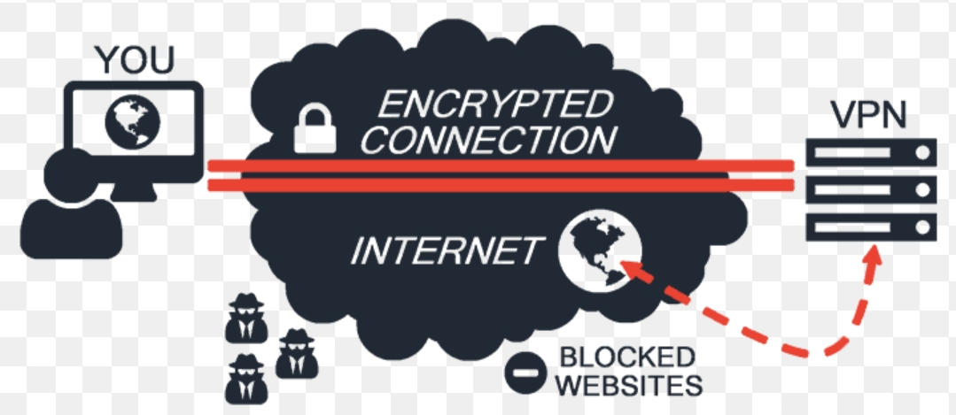

Encryption of protocols:- A VPN should also prevent you from leaving trances, for example, in the form of your internet history, search history and cookies. The encryption of cookies is especially important because it prevents third parties from gaining access to confidential information and others content on websites.

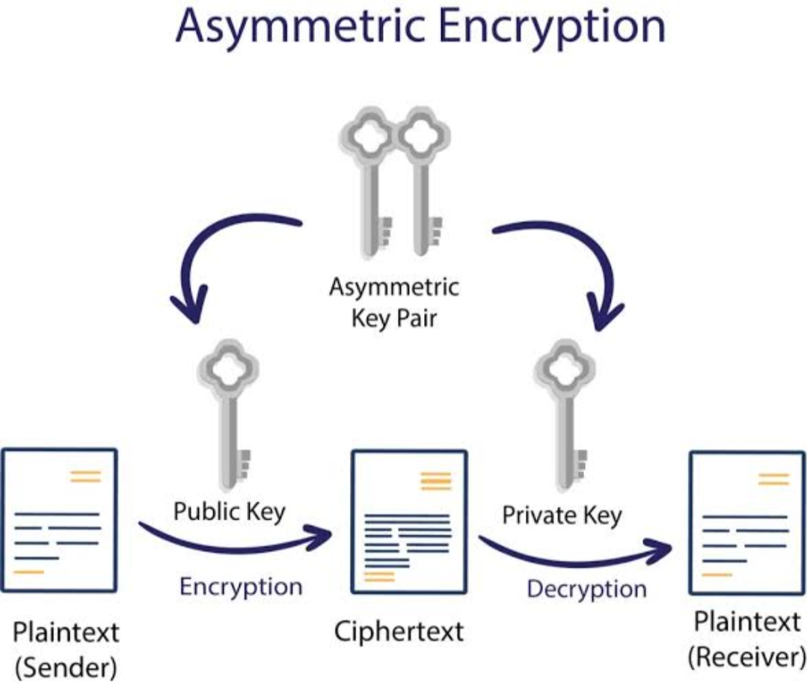
Kill switch:- If your VPN connection is suddenly interrupted, your secure connection will also be interrupt. A good VPN can detect this sudden downtime and terminate presented programs, reducing the livelihood that data is compressed.

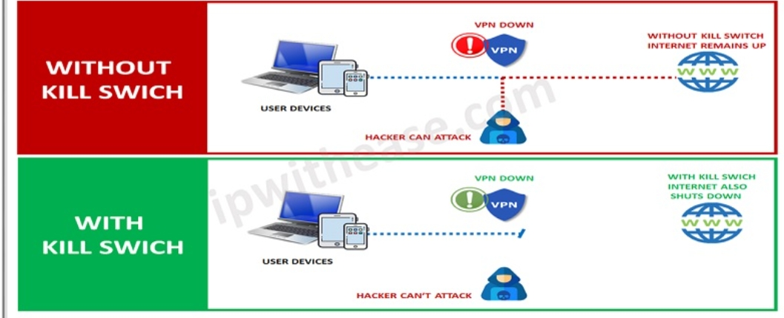

Kill Two- factor authentication- By using a variety of authentication methods, a strange VPN checks everyone who tries to log in. For example you might be promoted to enter a password, after which a code is sent to your mobile device. This makes it difficult for uninvited third parties to access your secure connection.

